**Phase 2**

*Experimental Results –*

Angle of repose is one of the most important physical properties when it comes to powder flowability. It characterizes a powders ability to move over itself and its tendency move when subjected to external forces. The angle of repose, θ, is the angle that a powder makes when poured over a flat, circular surface (Fig. 1).

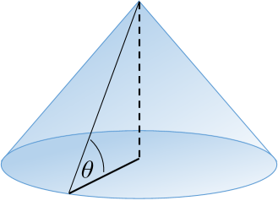 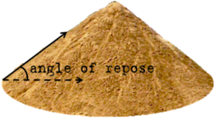

**Figure 1.** Angle of repose shown pictorially.

The angle of repose can change drastically depending on the chemical makeup of the material being tested. The team wanted to investigate how various excipients used in our formulation affect the angle of repose, and thus the powders overall flowability. Small experiment was conducted in which the 3 excipients: talc, dextrose, and fiber, were mixed with various ratios and then tested for their angle of repose. A table summarizing the testing ratios is provided below:

|  |  |  |  |  |  |
| --- | --- | --- | --- | --- | --- |
|  | **Talc** | **Dextrose** | **Fiber** | **Total** | **Mass Fraction of Variable (g/g)** |
| *Talc* | 2 | 3 | 4 | 9 | 0.22 |
| 3 | 3 | 4 | 10 | 0.30 |
| 5 | 3 | 4 | 12 | 0.42 |
| *Dextrose* | 3 | 2 | 3 | 8 | 0.25 |
| 3 | 3 | 3 | 9 | 0.33 |
| 3 | 5 | 3 | 11 | 0.45 |
| *Fiber* | 3 | 4 | 2 | 9 | 0.22 |
| 3 | 4 | 3 | 10 | 0.30 |
| 3 | 4 | 5 | 12 | 0.42 |

The materials were massed out, mixed, poured onto a beaker, and the heights of each pile was found. Using the height and the known diameter of the testing surface (beaker), we can calculate the angle of repose, θ, with the following formula:

$$θ = \tan^{-1}\left(\frac{h}{D/2}\right)$$

Fig. 2 graphically shows how the change in mass fraction of the variable substance affects the material’s angle of repose:

**Figure 2.** Angle of Repose, as it is affected by various excipients in formulation.

One can quickly see that the more talc included in the formulation, the lower the angle of repose. This makes sense as talc is used as a glidant. In addition, Fiber increases the angle of repose. Again, this makes sense since fiber is typically composed of large, branched and polymerized molecules that can stick together. Finally, the dextrose showed almost no affect on the angle of repose. Thus, it makes sense to try and optimize the talc and fiber content of our formulation. For now, we will say that the **optimized formulation** is the point at which the fiber and talc curves cross – about 0.275 (g/g) of fiber and talc. Which leaves us with ~ 0.45 (g/g) of dextrose.

Ignoring the effect of the product on the angle of repose, we can then extrapolate out to the stream requirements for our process when mixing the dried product with the excipients:

Mixer

**Dry Product, 20 kg/hr**

**Talc, 5.5 kg/hr**

**Fiber, 5.5 kg/hr**

**Dextrose, 11.1 kg/hr**

**Final Formulation, 40 kg/hr**